COGNIZANT DEEP SKILLING

WEEK 1

MODULE 3 : PL/SQL

EXERCISE 1 : CONTROL STRUCTURES
OUTPUT
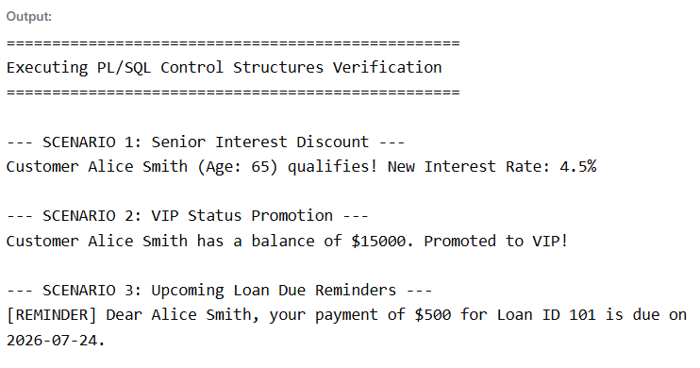

EXERCISE 3 : STORED PROCEDURES
